World Federation of Pediatric Imaging

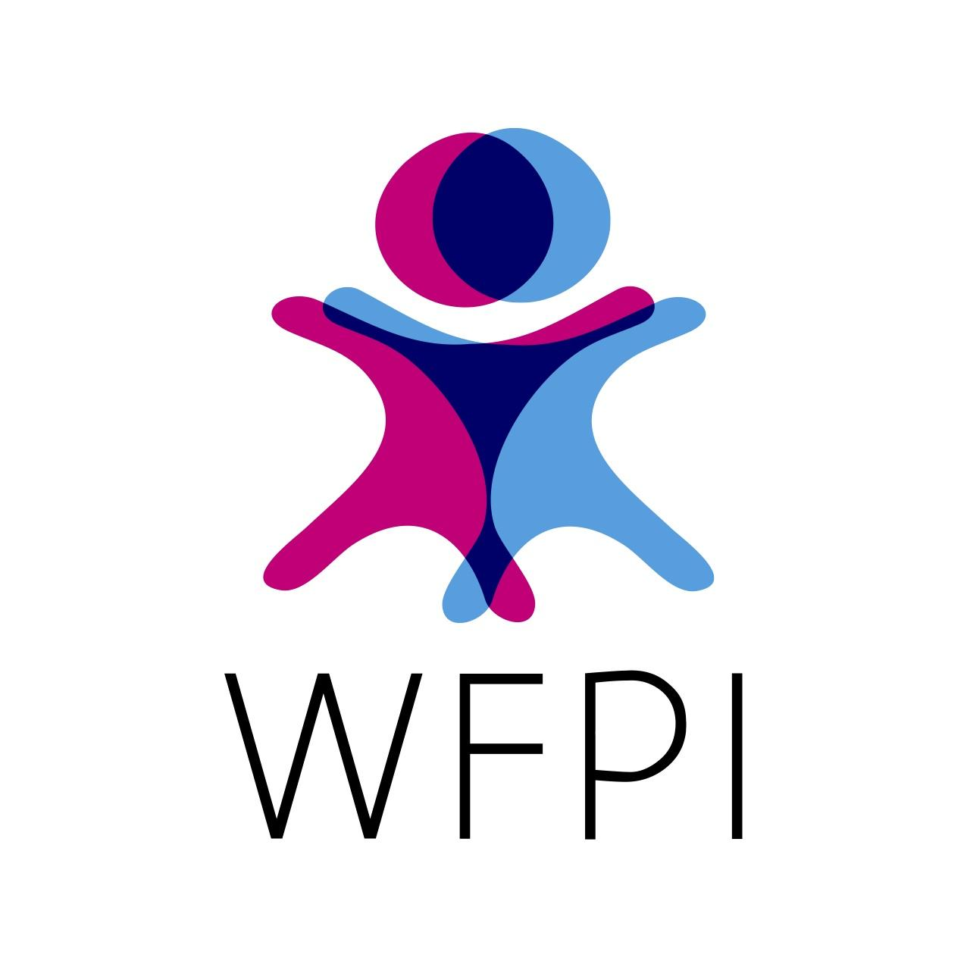
www.wfpiweb.org

Strategic Framework Update
2022 – 2027

Introduction

The World Federation of Pediatric Imaging was established in 2011 acknowledging that Diagnostic imaging services offered in modern medical settings have evolved enormously in recent decades, but even state-of-the-art healthcare can overlook the specificities of pediatric imaging. Imaging children requires understanding the unique needs of the patient and family. A child is not a small adult; knowledge of illnesses and medical conditions specific to the pediatric population is a necessity. Equipment, procedures and staff need to be oriented to the special needs of children. Radiation safety, in particular, needs to be specifically addressed in this young population. Subspecialty training in pediatric radiology requires years of medical school, residency and fellowship – requirements which can impose a strain on the world’s most advanced care centers.

When WFPI was established, organizers acknowledged that we - organizations dedicated to pediatric imaging around the world - had the opportunity to make substantive positive change, simply by working together using now widely available communication technologies.

We refer the reader to WFPI’s most recent prior Strategic Framework 2016-21 for the complete discussion of our original and continuing justification. This document is an update, highlighting new
areas of focus and recommitting to prior areas of focus.

- Structure and governance
There is no change to the WFPI’s governance structure. WFPI is composed of pediatric imaging organizations and its governing Council includes representation from North America, Europe, South America, Asia-Pacific and Africa. To foster the WFPI’s global span, membership is open to other regional societies and national and supranational organizations, whether pediatric imaging-centered (“full” members) or radiology organizations with pediatric sections/special interest groups and organizations for all professions related to medical imaging (“associate”, non-voting, members). Together, the WFPI’s organizational members offer extensive international reach in access to educational platforms, meetings, conferences, training courses, publications, contacts and networks.

Efforts are underway to identify contacts in areas not yet represented in the governance structure - Middle-East and Caribbean.
- Working Priorities
  - Communication and collaboration between pediatric imaging practitioners, via their organizations and forming collaborative relationships with active outreach organizations to “bolt-on” where possible. Re-Confirmed
    - Fueled by its inclusive set-up (all 5 regions with equal voting weight at board and where possible, committee-levels), WFPI aims to facilitate communication and collaboration among physicians, providing a united front in raising awareness of the multiple needs of pediatric imaging and optimizing the sharing of resources and expertise. From this communication and collaboration, all else flows.
    - When this document was ratified (early 2022) the WFPI was formally allied with WHO, IAEA, ISR, MSF, RAB, and WFUMB. These relationships establish the pipeline for pediatric radiology expertise to be included in the efforts of these larger organizations.
  - Virtual education – A consequence of the Global COVID 2019 pandemic was the explosion of available online education. WFPI participated in this development and launched a webinar series and captured the content for on-demand viewing on the WFPI YouTube Channel. Re-confirmed and advanced
  - Outreach and training in lower resource settings - Pursuant to this goal, in 2018, WFPI established the Pediatric Radiology Observership Program, which facilitates national or regional centers hosting local radiologists for 3-month pediatric radiology Observerships.
    - Tele-radiology – WFPI teleradiology services remain a valuable tool for outreach. Maintaining the legal and operational framework, teleradiology aims will transition from a service to places without access to radiologists to a peer-to-peer true-second opinion depository for complicated cases and advanced imaging, as a tool to support radiology colleagues without pediatric sub specialization and in small practices. Re-confirmed and advanced
    - The WFPI’s approach to outreach and training differs from one region to another, reflecting the diversity in imaging care. In some areas such care is simply unavailable; in others general physicians, nurses and technologists struggle to interpret x-rays. In rural settings where alternative diagnostic tools are non-existent or inadequate, assistance via radiograph-reporting can prove life-saving – notably for HIV/AIDS and tuberculosis. And where adequate equipment and/or medical teams do exist, they may need further training and engineering support to provide sustainable imaging care.
From 2018-2020, WFPI organized 5 such programs. The program went on hiatus mid-2020 because of the COVID pandemic but is re-launching in 2022. Re-confirmed and advanced.
  - Radiation safety and protection – WFPI and its leaders participate in radiation safety forums in South America, Japan, Switzerland and East Africa, it recognizes the need to coordinate comprehensive global promotion and support. Operating with partners such as the World Health Organization (WHO) and the International Atomic Energy Agency (IAEA), Reconfirmed.
  - Childhood Tuberculosis (TB) – TB remains a global public health concern with one-third of the world’s population being infected. Its burden is enormous, and it ranks as the second leading cause of death from a single infectious agent, after HIV - Reconfirmed
  - Fostering the increased use of ultrasound in lower resource settings - US is an ideal imaging tool for undeserved areas because it is relatively inexpensive, portable, does not require sedation and does not use radiation. The availability of equipment has encouraged non-radiologists to get training in focused point-of-care ultrasound. Reconfirmed.
- Resources
  - Website - WFPI uses its website – www.wfpiweb.org – as a platform to disseminate education to pediatric radiologists, radiologists, radiographers, and other medical professionals who do not have special pediatric expertise.
  - Harnessing social media – Facebook, Twitter and YouTube - for disseminating selected educational content - As Internet traffic moves away from laptops/desktops onto handheld devices, WFPI’s aims to harness the social media and apps they access to spread free education, disseminating its offerings across Facebook, Twitter, YouTube and other channels.
- Aspirations
  - Pediatric radiology research poses more challenges than adult or even pediatric medical research in general: low patient numbers, high ethical demands, little industry and pharmaceutical support due to low equipment sales and low drug use, lack of research personnel (radiologists, physicists, statistical experts etc.) and increasing demands in justification, optimization and, in particular, radiation protection and safety. Yet there is an urgent need for multidisciplinary, multi-institutional, multinational and prospective research on highly relevant topics impacting cost effectiveness, life quality and society. Existing pediatric radiology “guidelines” are more opinions or results drawn from consensus meetings rather than evidence-based.

In early 2022, the Executive Committee established a Research Committee. A first step to addressing this important aspiration. Early view of potential:

    - optimize the WFPI network for research - members will be encouraged to use the WFPI network to identify research opportunities and multi-center collaboration; the WFPI could act as a broker between institutions, and
    - harness the WFPI network to propose research on agreed upon general and specific topics (TB, AIDS, etc.) steered by experts within the WFPI to the benefit of children worldwide.
- Organizational performance
  - Leadership – unchanged
  - Administration and Staff – The WFPI staffing model has evolved from its early days of employing a half-time General Director to now (2021 - ?) employing the former, retired SPR Executive Director to work up to 10 hours per week. This arrangement is possible because of the excellent foundational work done by the original General Director, Amanda Dehaye. It is successful because of the willingness of the volunteer leadership to devote their time and energy.
WFPI operates with some donated administrative support from the Society for Pediatric Radiology (accounting and other infrastructure.)
  - Institutional communications - The Council and Committee leaders seeks to communicate with WFPI organization members and the individual physicians who constitute them via social media followings, its website and its quarterly newsletters circulated via social media outlets and WFPI member organizations themselves. In 2021, we began developing a “Mailing list” to include the past and present leaders of every member (National and regional) member organization.
- Financial Status –
As a “satellite” organization, WFPI has received capital injections during its initial years from those “parent” founding societies whose resources allow. WFPI extends its grateful thanks to the SPR’s R&E foundation, the SPR and the ESPR, along with individual donors and its member organizations paying fees.

WFPI’s financial situation, however, remains precarious, with no steady stream of revenue secured, and fund raising remains a challenge. Stand-alone individual project work is considerably easier to finance than fueling communication and collaboration between physicians and helping others make the starfish saves. But such comprehensive project work vastly outstrips our ambitions, time, and expertise. The consequent limits on our resources render the honing and re-honing of our mandate critical.

Conclusion
Ten years into its existence, WFPI seeks to create tools and generate resources that can be leveraged by multiple groups to be used where the need/desire for that expertise arises – be they high resource settings, middle income, or low (with a particular focus on low, given the massive imbalance of global resources and the high number of children living in these areas). And while this choice may not have the direct “feel-good” of a more focused or direct intervention, it is nonetheless relevant and impactful, and has the chance to make change. In its self-styled “octopus” role, WFPI can keep hold of the big picture, reduce naïveté, provide tools and increase the chances of success in the international work its members undertake.

Founding societies: the Society for Pediatric Radiology, the European Society of Pediatric Radiology, the Latin American Society of Pediatric Radiology, the Asian and Oceanic Society for Pediatric Radiology. Joined later: the African Society of Pediatric Imaging.
Supranational organizations are built up on linguistic or other, non-geographical criteria. E.G. Europe’s German-speaking pediatric radiology society (GPR) which draws members from Germany, Austria, Switzerland and the Netherlands.

